Accessibility Statement

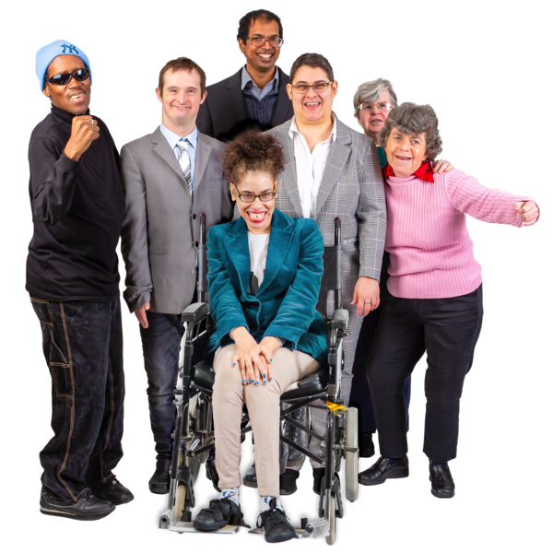 |  | This program was made for people with an intellectual disability.
 |  | We want this program to be accessible for everyone.  This means it is easy to use and understand.
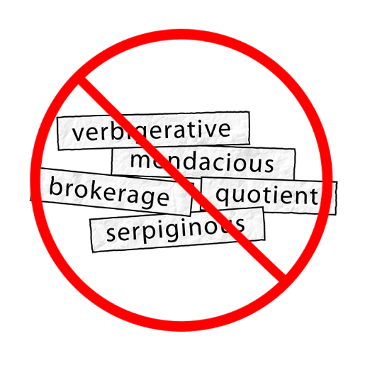  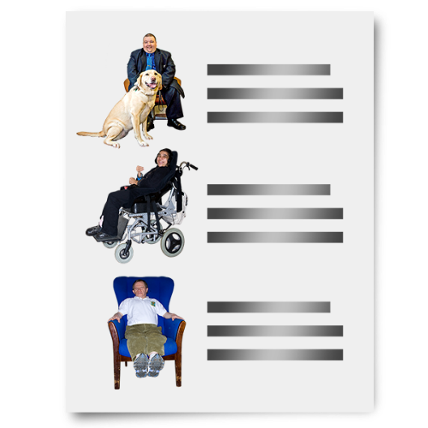  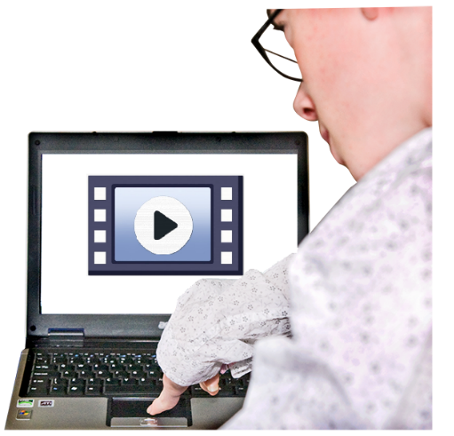  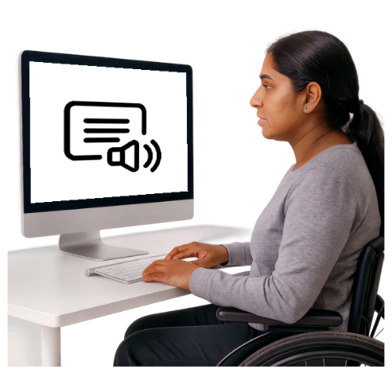  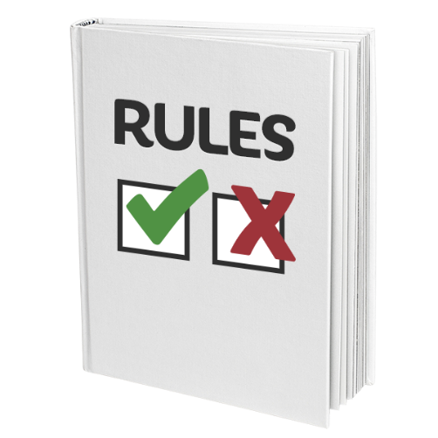 |  | Some of the ways we did this:  - We used easy words  - We made the pages easy to move through  - We used pictures and examples to help explain what things mean  - We got people with lived experience to test the program  This means people with an intellectual disability  - We made sure the program works with screen readers and text-to-speech technology.  The program meets Level AA WCAG 2.1 rules.  WCAG 2.1 rules are online rules about accessibility.  Level AA means it is very accessible.
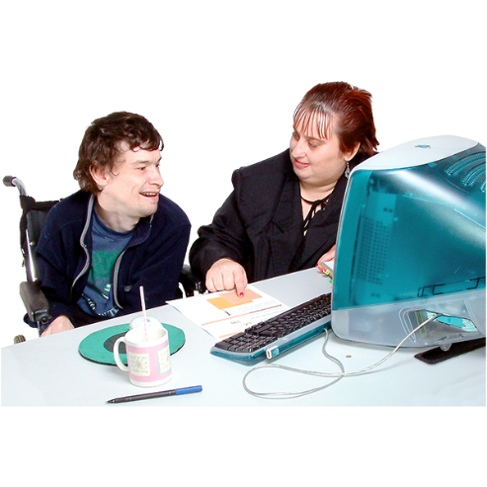  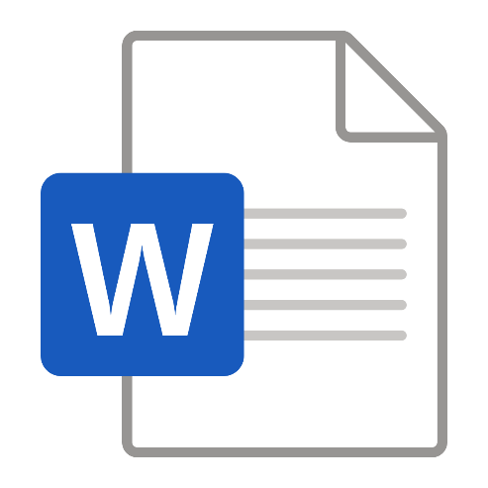 |  | If you find it hard to use this program you can  - ask a support person for help  - download the information in this program as a Word document from the Home page.

